Deliverable 2 PIP Message Exchange

Xusheng Xiao

000954996

xxiao2@ncsu.edu

# 1. Account Setup and Maintain

* PIP 1A1: Request Account Setup
  + MedEq outsources manufacturing to two contract manufacturers: FlexMan and SoleMan and employs two shippers: FedUp and UpFed. Thus, MedEq needs to share information, such as locations and contacts, with these four companies.

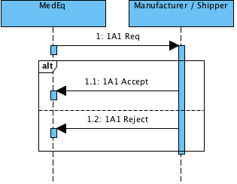

* PIP 1A2: Maintain Account
  + If MedEq or one of its business partners (FlexMan, SoleMan, FedUp, and UpFed) needs to change their information, they can use this PIP for sending change requests.

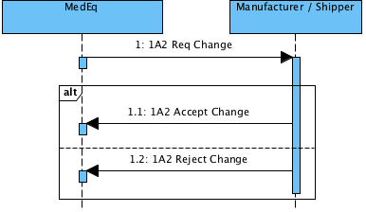

# 2. Order Management

* PIP 3A1: Request Quote
  + This PIP allows Customer to send their requirements to MedEq.

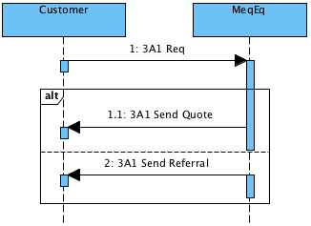

* PIP 3A2: Request Price and Availability
  + This PIP allows Customer to request the price and availability of the submitted requirements.

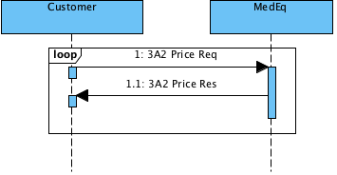

* PIP 3A4: Request Purchase Order
  + If MedEq and Customer agree on the price and requirements, the Customer can request a purchase order

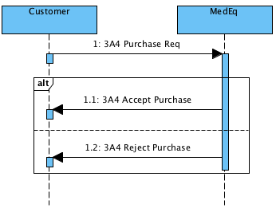

* PIP 3A9: Request Purchase Order Cancellation
  + If Customer does not agree on the price, he can cancel it.

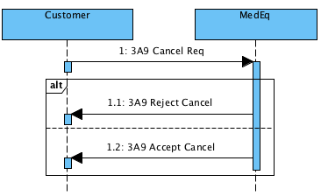

* PIP 3A10: Notify of Quote Acknowledgement
  + Customer can notify MedEq that he accepts or rejects the order based on the price

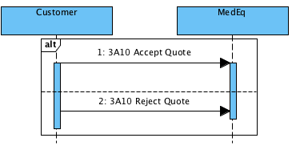

# 3. Shipment Management

* PIP 3B12: Request Shipping Order
* PIP 3B13: Notify of Shipping Order Confirmation

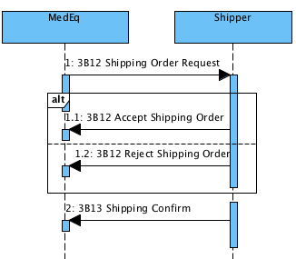

* PIP 3B3: Distribute Shipment Status
* PIP 3B4: Query Shipment Status

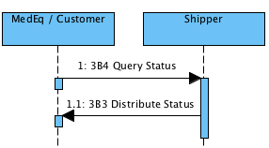

* PIP 3B5: Request Shipment Change
* PIP 3B6: Notify of Shipments Tendered

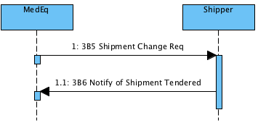

* PIP 3B14: Request Shipping Order Cancellation
* PIP 3B22: Notify of Shipping Order Cancellation Confirmation

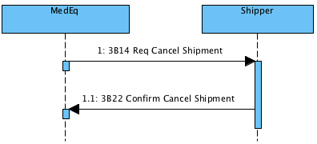

# 4. Stock Management

* PIP 4B2: Notify of Shipment Receipt
  + This enables a consignee, such as customer and MedEq, to report the status of a received shipment to another interested party, such as MedEq, FedUp, or UpFed.

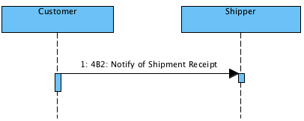

* PIP 4B3: Notify of Consumption
  + This enables MedEq to communicate the material information with contract manufacturers

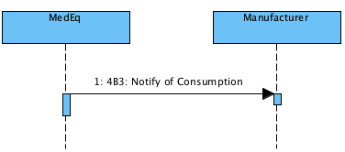

* PIP 4D1: Notify of Material Release
  + This enables MedEq to trigger a stock replenishment

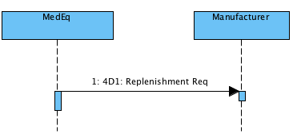

# 5. Manufacturing

* PIP 7B1: Distribute Work in Process
  + This enables the contract manufacturers (FlexMan, SoleMan) to notify MedEq the configuration status of the manufacturing of equipment

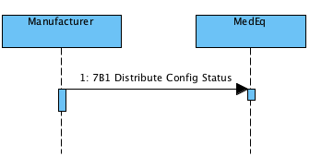

* PIP 7B2: Query Work in Process
  + This enables MedEq to query the status of the manufacturing equipment from the contract manufacturers (FlexMan, SoleMan)

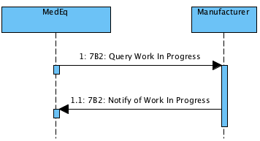

# 6. Return and Finance

* PIP 3C1: Return Product
  + This PIP enables customer to submit a request to return the equipment if it does not meet the requirements

